# IBMASSIGNMENT–2

DOMAIN :IOT

NAME : Keerthivasan.R

REGISTERNUMBER 714019106047

COLLEGE:SRISHAKTHIINSTITUTEOFENGINEERINGANDTECHNOLOGY

ASSIGNMENTQUESTION:

Builda python code, assume youget temperatureandhumidityvalues(generatedwithrandomfunctiontoavariable) andwriteaconditiontocontinuouslydetectalarmincaseofhightemperature.

# PYTHONCODE:

importrandomimp orttimewhile(1!=0): temperature=random.random()humi dity=random.random()

#round(temperature,2)#round(humidity,2)("printTempera ture:","%.5f" %temperature) print("Humidity:","%.5f"%humidity)time.sleep(2) if(temperature>0.7):print("hightempe

rature")

if( humidity>0.7): print("highhumidity")

print("")



EXECUTIONRESULT

# Program

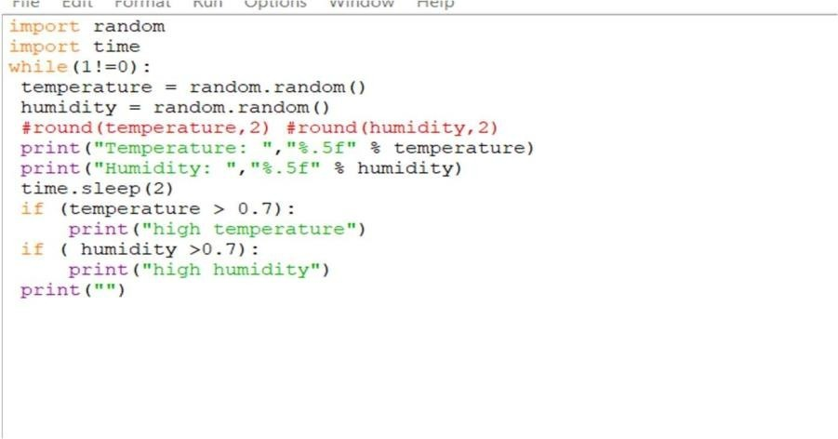

Output

